VOTE NOV 4TH


FOR A SAFER PHILADELPHIA
OFFICES: | REPUBLICAN ENDORSED CANDIDATES:
Supreme Court Judge Christine Donohue | DO NOT RETAIN
Supreme Court Judge Kevin M. Dougherty | DO NOT RETAIN
Supreme Court Judge David Wecht | DO NOT RETAIN
Judge of the Superior Court | MARIA BATTISTA
Judge of the Commonwealth Court | MATT WOLFORD
District Attorney | PAT DUGAN
City Controller | ARI PATRINOS
Judge of Elections (per division) | VOTE for the REPUBLICAN or write-in
Inspector of Elections (per division) | VOTE for the REPUBLICAN or write-in
YOUR VOTE COUNTS!

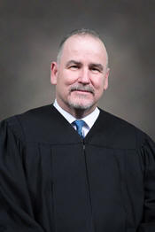
VOTE NOV 4th
Pat Dugan For DA

Respected President Judge
Dedicated Public Servant
Decorated Veteran
Proud Lifelong Philadelphian

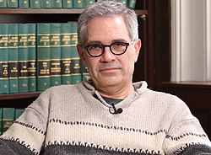
Real Clear Pennsylvania: “Krasner Has Been a Disaster for Philadelphians”
May 19, 2025: “Krasner has been a failure. In truth, he wasn’t aiming for the crime fighting. Instead, he focused on advancing a progressive, upside-down-and-backwards vision of “justice.” He chased away career prosecutors; argued for cashless bail; gave thugs successive “second-chances”; and essentially legalized shoplifting – forcing stores to close and making law-abiding citizens feel both cheated and unsafe. They helplessly watch theft occur in front of their eyes at Home Depot, CVS, Target, and Acme. Krasner hasn’t been the chief prosecutor. He’s been the chief crime-enabler.” by Guy Ciarrocchi


BEST REPORTER ON DA KRASNER’S “TOXIC JUSTICE”
RalphCipriano.substack.com
RalphCipriano.com/stories/big-trial/toxic-justice

Join Philly’s Republican Network
PhillysRep.Net
(This flyer is not officially endorsed by the GOP or any candidate)

